ASSIGNMENT -1
1.
<!DOCTYPE html>
<html>
<style>
h1{
background-color:red;
}
body{
background-color:yellow;
}
p{
background-color:green;
}
</style>
<body>
<h1>
This is heading
</h1>

<p>
This is a paragraph
</p>
</body>
</html>
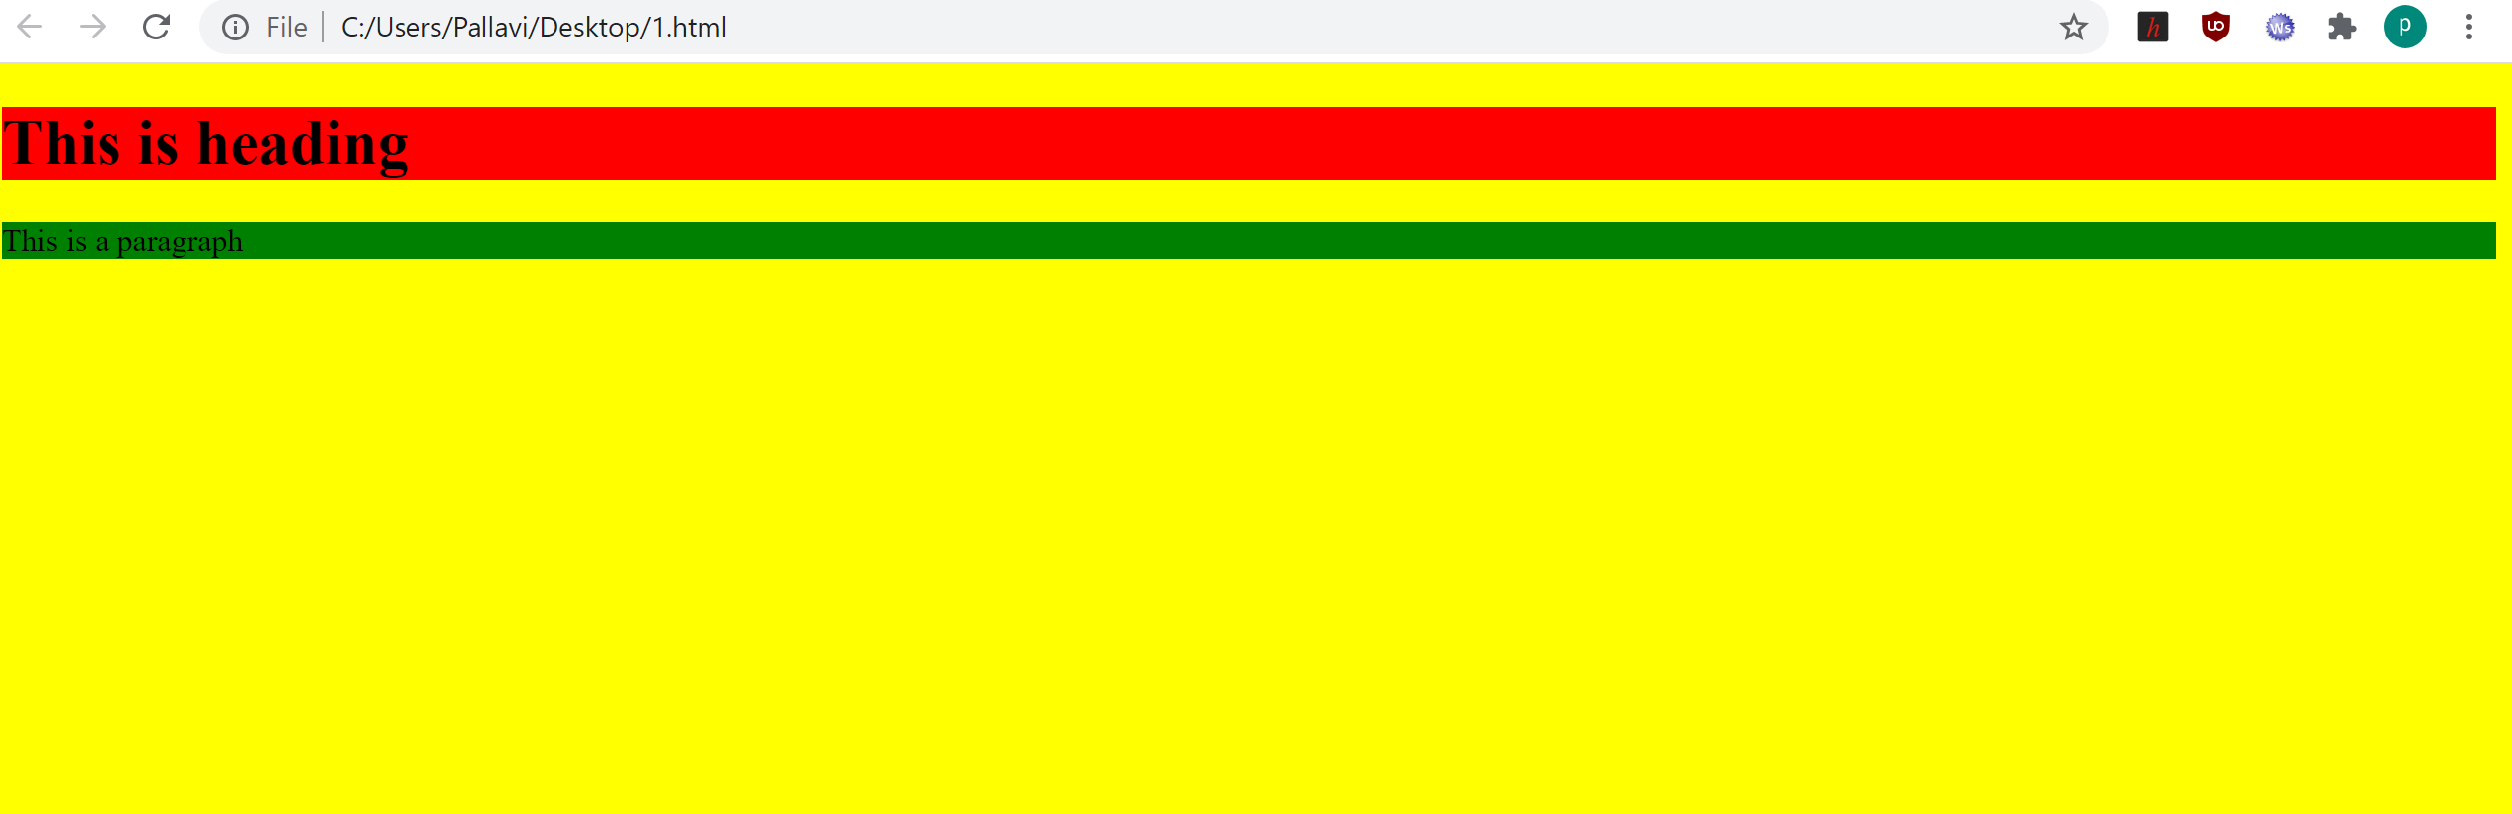

2.
<!DOCTYPE html>
<html>
<head>
<style>
div{
display:inline;
border :5px solid;
}
div img{
border : inherit;
}

</style>
</head>
<body>

<p>
create a link of an image
</p>
<div>
<img src =" https://www.ikea.com/in/en/images/products/smycka-artificial-flower-rose-red__0903311_pe596728_s5.jpg ">
</div>
<p> No border around image,but still a link:</p>
<img src = "https://cdn.shopify.com/s/files/1/0035/2754/0782/articles/International_Flower_Day_2048x.jpeg?v=1579365491 ">

</body>
</html>




3.
<!DOCTYPE html>
<html>

<style>

td{
border : 1px solid black;
}
</style>
<table>
<tr>one column:
<th>
<td>
100
</td>
</tr>
</table>

<table>
<tr>one row and three columns:
<th><td>100</td></th>
<th><td>200</td></th>
<th><td>300</td></th>
</tr>
<tr>
<th><td>400</td></th>
<th><td>500</td></th>
<th><td>600</td></th>
</tr>
</table>
</html>

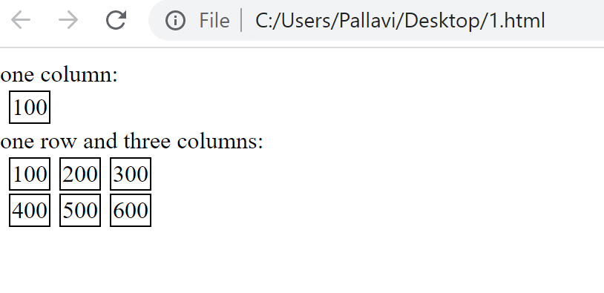

4.

<!DOCTYPE html>
<html>

<body>

<h2> This table has borders:</h2>
<table>
<style>
table, th, td {
border: 1px solid black;
border-collapse: collapse;
}
</style>

<table style="width:100%">
<tr>
<th><td>100</td></th>
<th><td>200</td></th>
<th><td>300</td></th>
</tr>

<tr>
<th><td>400</td></th>
<th><td>500</td></th>
<th><td>600</td></th>
</tr>

</table>

</body>
</html>

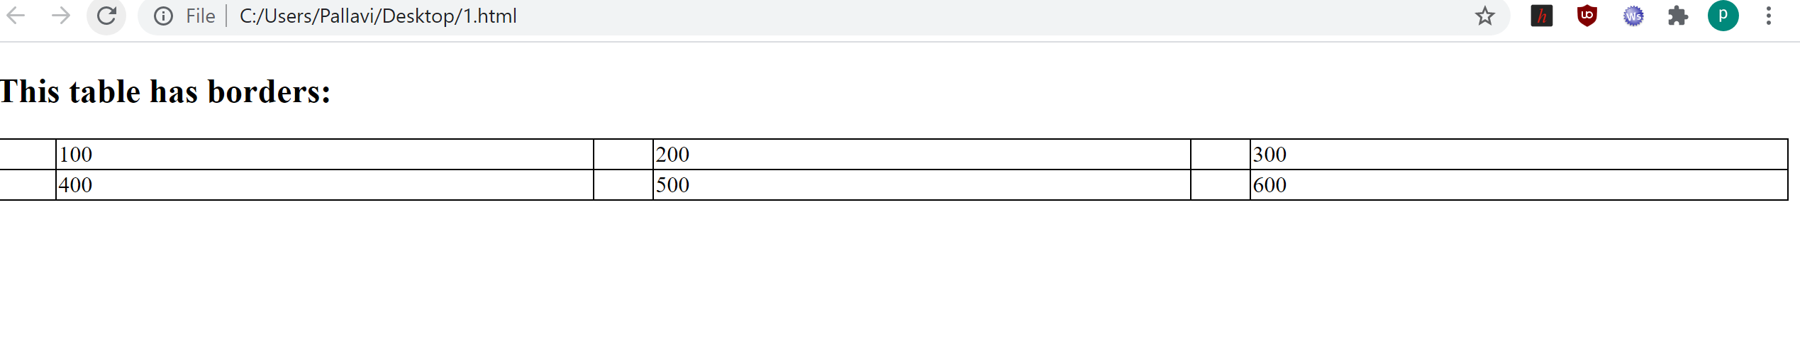

<!DOCTYPE html>
<html>

<body>
<h2>And this table has no borders:</h2>
<table>
<tr>
<td>100</td>
<td>200</td>
<td>300</td>
</tr>
<tr>
<td>400</td>
<td>500</td>
<td>600</td>
</tr>
</table>

</body>
</html>

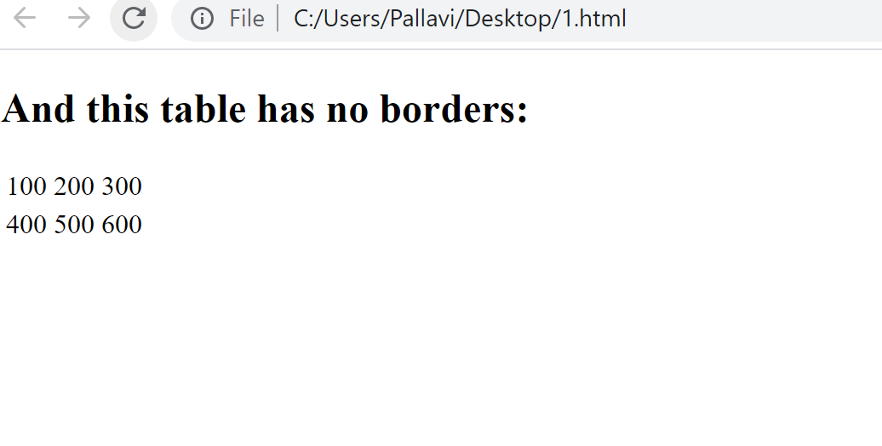

5.
<!DOCTYPE html>
<html>
<h3> Numbers list: </h3>
<ol type = "1">
<li>Apples</li>
<li>Bananas</li>
<li>Lemons</li>
<li>Oranges</li>
</ol>
<h3>Letters list: </h3>
<ol type ="A">
<li>Apples</li>
<li>Bananas</li>
<li>Lemons</li>
<li>Oranges</li>
</ol>
<h3> Lowercase Letters list:</h3>
<ol type ="a">

<li>Apples</li>
<li>Bananas</li>
<li>Lemons</li>
<li>Oranges</li>
</ol>
</ol>
<h3> Lowercase Roman Number list:</h3>
<ol type ="i">

<li>Apples</li>
<li>Bananas</li>
<li>Lemons</li>
<li>Oranges</li>
</ol>
</ol>
<h3> Roman Number list:</h3>
<ol type ="|">

<li>Apples</li>
<li>Bananas</li>
<li>Lemons</li>
<li>Oranges</li>
</ol>

</html>

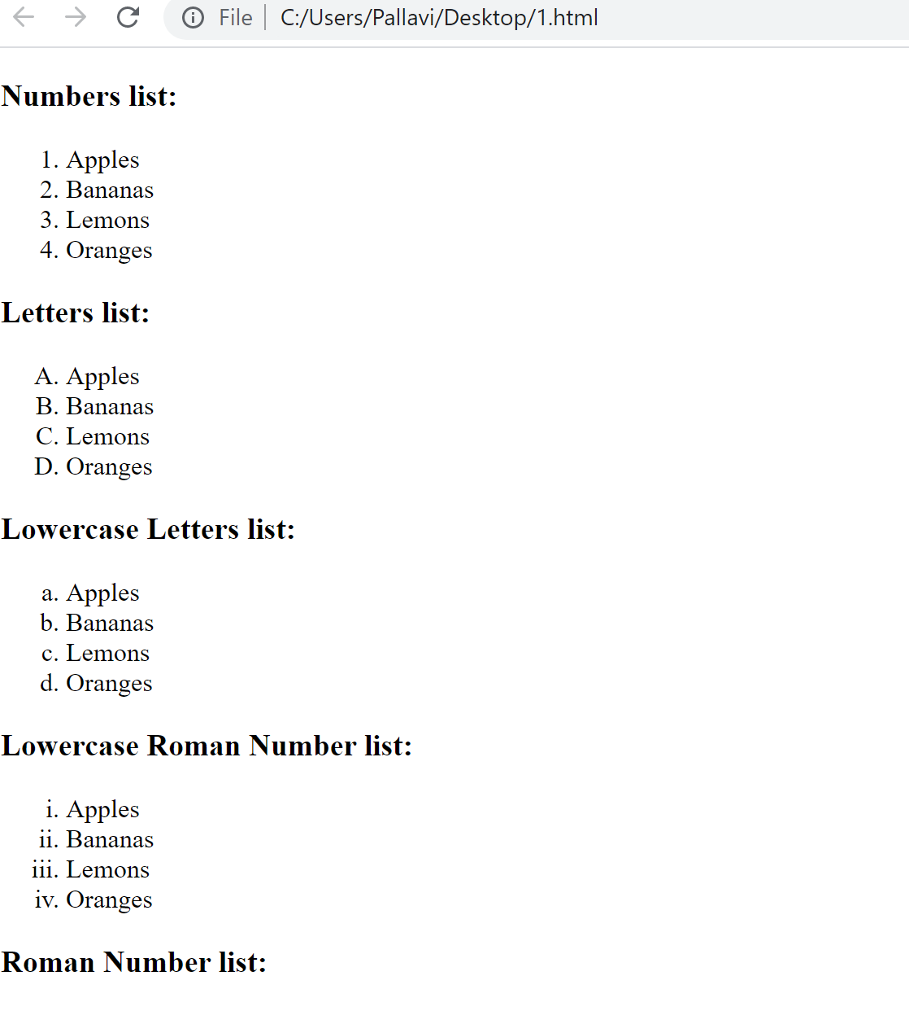

6.
<!DOCTYPE html>
<html>
<form>
<label>Username : </label>
<input type = "text" id ="Username">
<br>
<label> Passwrod: </label>
<input type = "Password" id ="Password">
</form>
</html>

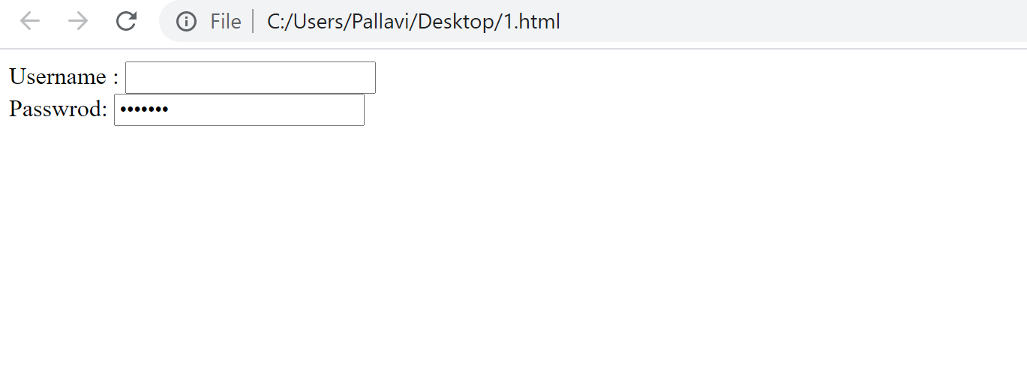

7.
<!DOCTYPE html>
<html>

<input type = "radio" id ="radio">
<label for = "radio"> I have a bike </label>

<br>

<input type = "radio" id ="radio">
<label for = "radio" >I have a car </label>
<br>
<input type = "submit" value = "submit the form ">

</html>

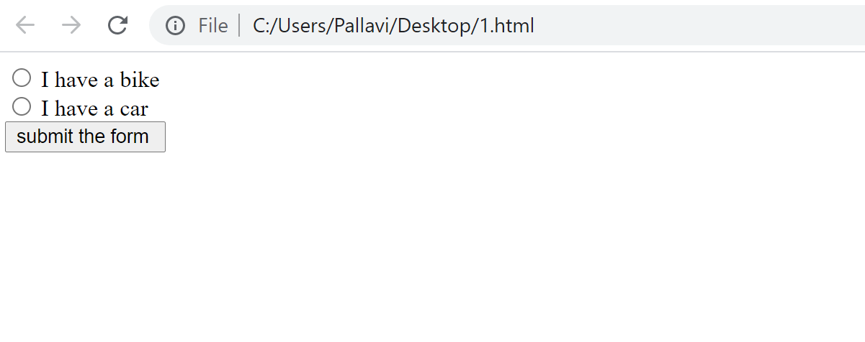

8.
<!DOCTYPE html>
<html>
<body>
<table border = "1">
<tr>
<th>
<td colspan = "2" bgcolor = "green" > top </td>
</th>
</tr>

<tr>
<th>
<td bgcolor="grey">left</td>
<td bgcolor="grey”>right</td>
</th>

</tr>

</body>

</html>

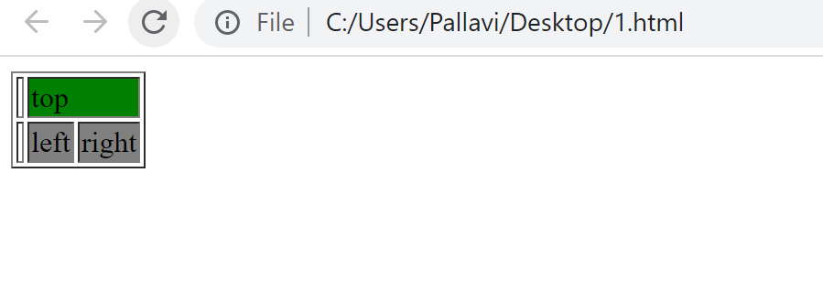

9.
<!DOCTYPE html>
<html>
<body>
<table border = "1">
<tr>
<th>
<td bgcolor="green"> topleft</td>
<td bgcolor="yellow"> topright</td>
</th>
</tr>

<tr>
<th>
<td bgcolor="blue"> left</td>
<td bgcolor="red"> right</td>
</th>

</tr>

</body>

</html>
